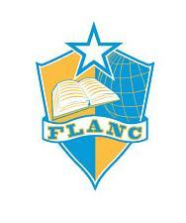
Focus Learning Academy of Northern Columbus
1880 E. Dublin Granville Rd., Columbus Ohio 43229
(614) 547-0920 (office) ∙ (614) 547-0924 (fax)

Notice of Parents Right-to-Know
Date: To be sent at the beginning of the school year, included in re/enrollment procedure, posted on Website.
RE: Every Student Succeeds Act (Public Law 114-95), Section 1112 (e)(1)(A)
Dear Parent/Guardian:
You have the right to know about the teaching qualifications of your child’s classroom teacher in a school receiving Title I funds. The federal Every Student Succeeds Act (ESSA) requires that any school district receiving Title I funds must notify parents of each student attending any school receiving Title I funds that they may request, and the district will provide the parents on request (and in a timely manner), information regarding the professional qualifications of the student’s classroom teachers, including at a minimum, the following:
- Whether the teacher has met State qualification and licensing criteria for the grade levels and subject areas in which the teacher provides instruction;
- Whethertheteacheristeachingunderemergencyorotherprovisionalstatusthrough which State qualification or licensing criteria have been waived; and
- Whether the teacher is teaching in the field of discipline of the certification of the teacher;
- Whether your child is provided services by paraprofessionals and, if so, their qualifications.
You may ask for the information by returning this letter to the address listed above or you may e-mail your request. Be sure to give the following information with your request:
Child’s full name __________________________________________________
Parent/guardian full name ____________________________________________
Address ______________________________________________________________
City, state, ZIP __________________________________________________
Teacher’s name __________________________________________________
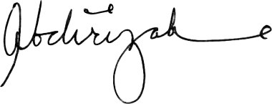
Sincerely,
Abdirizak Farah

